WATER EQUALS LIFE

Kotor, the town with three gates, is said to be created by three fairies: the sea, the mountain and the sky one. This UNESCO world heritage site of rich tradition and culture, yearly visited by about half a million of tourists, has survived many storms and adversities. Today, it faces a different kind of danger. In the 21st century, Kotor is a thirsty town. Almost all the municipal areas are under restrictions.
During the summertime, the town lying on three waters faces the natural phenomenon of salination to the sources of Škurda and Orahovac, their “retreats” and deficiency of water. The problem is further complicated by the outdated water supply network and bad quality of piping materials, thus the Water Supply Company encounters about 80% of losses in the water supply network.

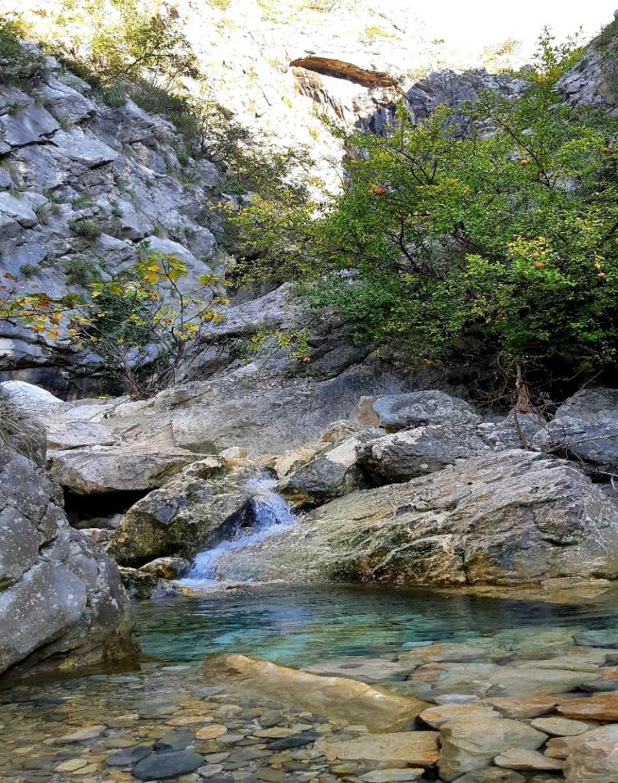
The River Škurda spring – a magical place bursting with ancient power. While flowing, it fearlessly conquers the unconquerable. Each spring drop of water is a God’s gift.
Every morning, before opening their taps, the inhabitants of Kotor need to check with the local public broadcasting if the water is potable or not. Of course, if they are lucky to have it for the day. The fact that the people of Kotor have salinated, non-potable and chlorinated water, and at the same time the most costly one in the region, provokes a revolt.

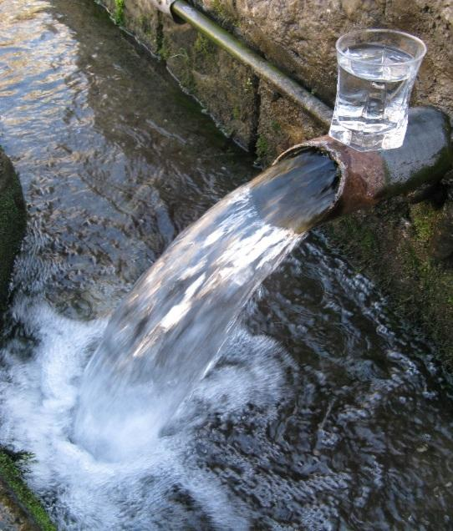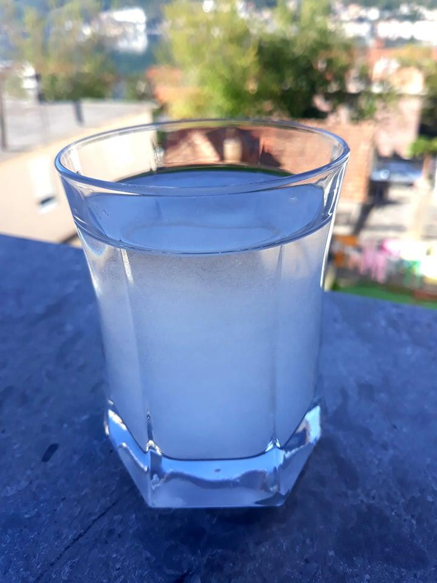
Spring water Tap water
The local residents have every right to protest and wonder whether the Water Supply Company is aware of the fact that they encourage the worsening of the epidemic and spread of the coronavirus infection. During the epidemic, putting the emphasis on washing hands, the inhabitants of Kotor and their guests can perform hygienic practices once the salinated water comes again.
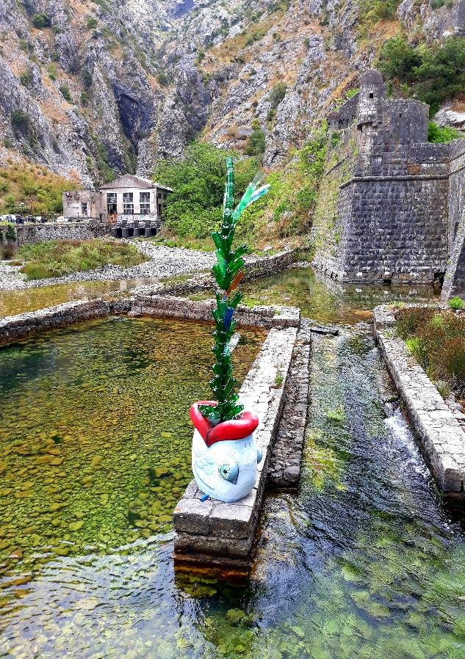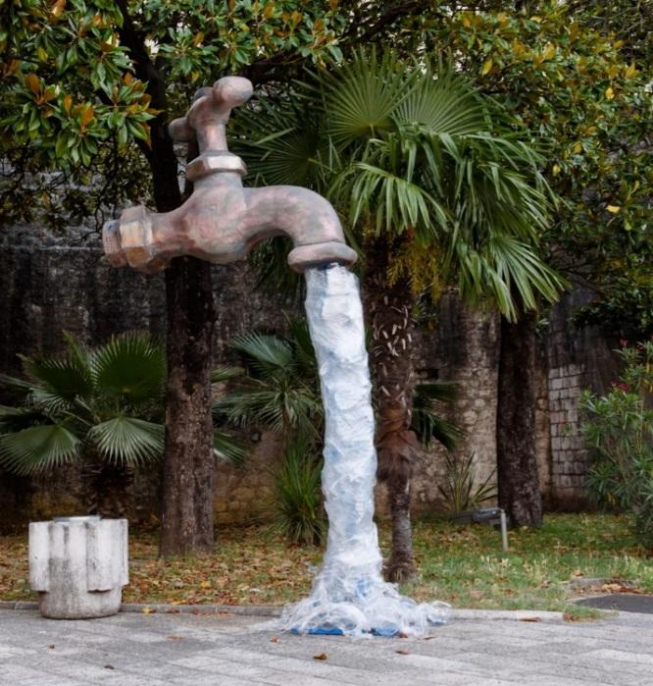
If you listen carefully, you can hear them sob, cry, laugh, whisper, grieve…
Thus far, the authorities have not provided us with any response regarding the permanent solution to this years-long problem. For now, all we know is that the first rainfalls are going to bring us water till next summer. And then…there is hope…both anxiety and hope…

Nikola Kovač, grade IX-2
Teacher: Aleksandra Sindik Milićević „Narodni heroj Savo Ilić“ PS
Dobrota - Kotor

